7659 HW5

Guannan Shen

October 22, 2018

Table of Contents

## set up workspace  
library(knitr)  
library(tidyverse)  
library(RNASeqPower)  
library(edgeR)  
library(cqn)  
library(EDASeq)  
library(yeastRNASeq)  
options(stringsAsFactors = F)  
options(dplyr.width = Inf)  
getwd()

## [1] "/home/guanshim/Documents/Stats/CIDA_OMICs/7659Stats_Genetics/HW5"

## not in function  
"%nin%" <- Negate("%in%")

# HW5

## 1. Next Generation Sequencing: Sample Size Estimates

### (a) Using rnapower(), recreate Figure 3 from the journal club paper, Hart.

## montgomery data from cqn  
data(montgomery.subset)  
## GC and gene length of montgomery  
data(uCovar)  
## vector of length 10 containing the number of mapped reads  
## for each sample  
data(sizeFactors.subset)  
  
########## Understand the dataset ######## help(montgomery) number of  
########## genes genes that have zero counts in all 10 samples were  
########## already excluded  
ng_mont <- nrow(montgomery.subset)  
  
############## Question 1 figure 3 ################ sample size (ss) vs  
############## depth sample size per group  
ssize_depth <- sapply(c(0.4, 0.8, 1.2), function(y) {  
 sapply(1:50, function(x) {  
 rnapower(depth = x, cv = y, effect = 2, alpha = 0.05,   
 power = 0.8)  
 })  
})  
ssize_depth <- data.frame(ssize_depth)  
colnames(ssize_depth) <- c("V1", "V2", "V3")  
  
### Plot  
ggplot(ssize_depth, aes(x = 1:50)) + geom_line(aes(y = V1, color = "CV = 0.4")) +   
 geom_point(aes(y = V1, color = "CV = 0.4")) + geom_line(aes(y = V2,   
 color = "CV = 0.8")) + geom_point(aes(y = V2, color = "CV = 0.8")) +   
 geom_line(aes(y = V3, color = "CV = 1.2")) + geom_point(aes(y = V3,   
 color = "CV = 1.2")) +   
scale_x_discrete(name = "Depth of Gene", limits = c(1:50)) +   
 scale_y_continuous(name = "Sample Size Needed per Group ",   
 breaks = c(0, 10, 20, 30, 40, 50, 60, 70, 80)) + theme_bw() +   
 scale_colour_manual("", breaks = c("CV = 0.4", "CV = 0.8",   
 "CV = 1.2"), values = c(`CV = 0.4` = "grey", `CV = 0.8` = "yellow",   
 `CV = 1.2` = "brown"))

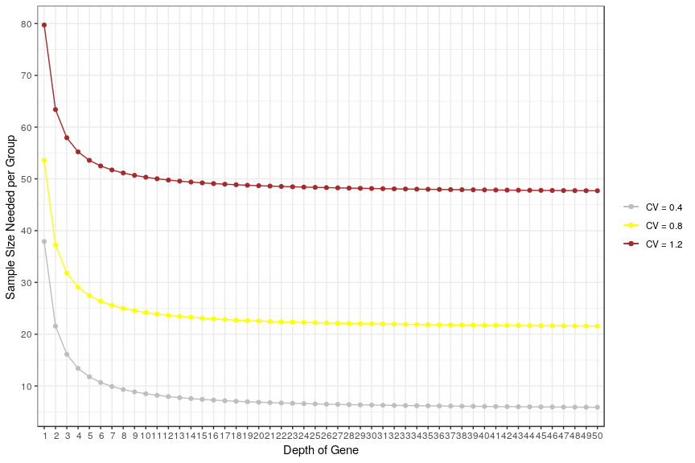

### (b) For the Montgomery data, create a row in Table 1 in the Hart et al. paper.

########## average of sequence reads aligning to the gene/ depth  
########## ############ how many reads are assigned to a particular  
########## gene / depth ## is a data frame with 23552 observations on  
########## 10 different samples ##  
N_total <- sum(sizeFactors.subset)  
## number of genes genes that have zero counts in all 10  
## samples were already excluded  
ng_mont

## [1] 23552

counts_gene_million <- rowSums(montgomery.subset)/N_total * 1e+06  
  
mont_counts <- data.frame(Sample = "Montgomery", n = 10, Reads = round(N_total/(ng_mont *   
 10), 2), mapped = "100%", a = round(sum(counts_gene_million <   
 0.01)/ng_mont, 2), b = round(sum(0.01 <= counts_gene_million &   
 counts_gene_million < 0.1)/ng_mont, 2), c = round(sum(0.1 <=   
 counts_gene_million & counts_gene_million < 1)/ng_mont, 2),   
 d = round(sum(1 <= counts_gene_million & counts_gene_million <   
 10)/ng_mont, 2), e = round(sum(10 <= counts_gene_million &   
 counts_gene_million < 100)/ng_mont, 2), f = round(sum(100 <=   
 counts_gene_million & counts_gene_million < 1000)/ng_mont,   
 2), g = round(sum(1000 <= counts_gene_million)/ng_mont,   
 2))  
colnames(mont_counts) <- c("Sample", "n", "Avg Reads", "% mapped",   
 "<0.01", "0.01–0.1", "0.1–1", "1–10", "10-100", "100-1000",   
 ">1000")  
kable(mont_counts)

### 

### (c) Calculate the biological coefficient of variations (CV) from the Montgomery

## edgeR DGElist  
dge <- DGEList(counts = montgomery.subset, lib.size = sizeFactors.subset,   
 group = rep(1, length(sizeFactors.subset)))  
dge <- estimateCommonDisp(dge)  
dge <- estimateTagwiseDisp(dge)  
  
## the distribution of tagwise dispersion (genewise variation)  
par(mfrow = c(1, 2))  
hist(dge$tagwise.dispersion, breaks = 60)  
plot(ecdf(dge$tagwise.dispersion), ylab = "Fn(x)")

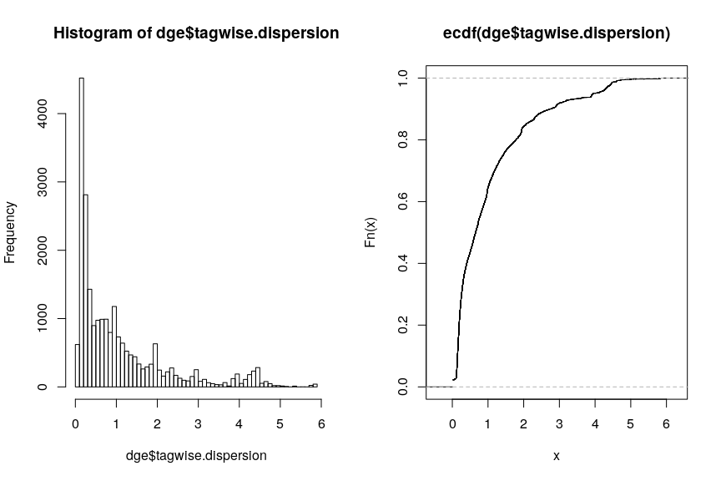

## median and 90% quantile  
med_mont <- median(dge$tagwise.dispersion)  
med_mont

## [1] 0.6530353

quan09_mont <- as.numeric(quantile(dge$tagwise.dispersion, probs = 0.9))  
quan09_mont

## [1] 2.75203

The median and 90% percentile of the tagwise dispersions of whole genes in the Montgomery dataset are 0.653 and 2.752, respectively.

### (d) Using rnapower(), recreate Figure 3 from Hart et al. again

## sample size (ss) vs depth sample size per group  
ssize_depth_mont <- sapply(c(med_mont, quan09_mont), function(y) {  
 sapply(1:50, function(x) {  
 rnapower(depth = x, cv = y, effect = 2, alpha = 0.05,   
 power = 0.8)  
 })  
})  
ssize_depth_mont <- data.frame(ssize_depth_mont)  
colnames(ssize_depth_mont) <- c("V1", "V2")  
  
### Plot  
ggplot(ssize_depth_mont, aes(x = 1:50)) + geom_line(aes(y = V1,   
 color = "Median CV")) + geom_point(aes(y = V1, color = "Median CV")) +   
 geom_line(aes(y = V2, color = "90% Quantile CV")) + geom_point(aes(y = V2,   
 color = "90% Quantile CV")) + scale_x_discrete(name = "Depth of Gene",   
 limits = c(1:50)) + scale_y_continuous(name = "Sample Size Needed per Group ",   
 breaks = c(50, 100, 150, 200, 250, 300)) + theme_bw() + scale_colour_manual("",   
 breaks = c("Median CV", "90% Quantile CV"), values = c(`Median CV` = "grey",   
 `90% Quantile CV` = "brown"))

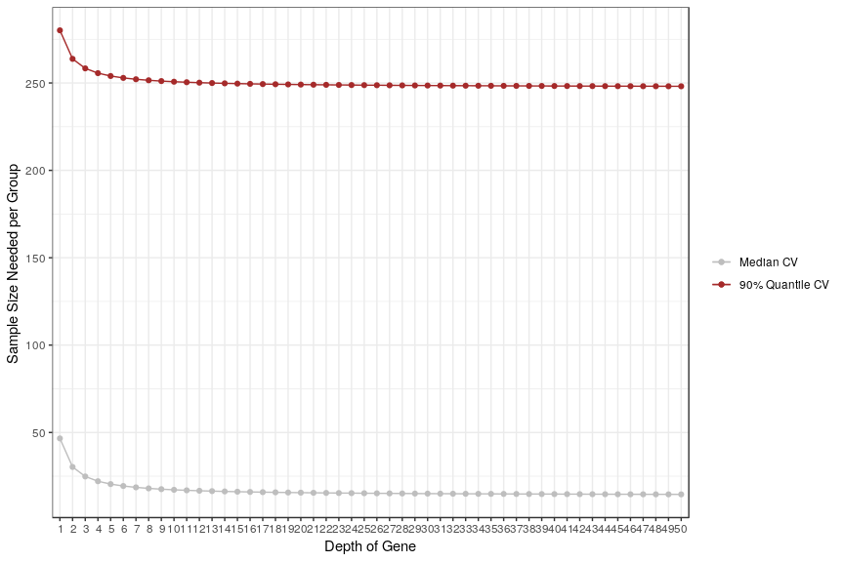

### (e) Using rnapower(), recreate the curve (not the histogram) in the top Figure 4

## power curve for n = 20 per group, coverage of 100, s = 0.32  
## (60th percentile of observed) and a = 0.001.  
s06 <- as.numeric(quantile(dge$tagwise.dispersion, probs = 0.6))  
p_curve <- sapply(seq(1, 8, by = 0.1), function(x) {  
 rnapower(depth = 100, cv = s06, n = 20, effect = x, alpha = 0.001)  
})  
p_curve <- data.frame(p_curve)  
colnames(p_curve) <- c("V1")  
  
### Plot  
ggplot(p_curve, aes(x = seq(1, 8, by = 0.1))) + geom_line(aes(y = V1,   
 color = "Power Curve")) + geom_point(aes(y = V1, color = "Power Curve")) +   
 scale_x_discrete(name = "Fold Change", limits = c(1:8)) +   
 scale_y_continuous(name = "Power ", breaks = c(0, 0.2, 0.4,   
 0.6, 0.8, 1)) + theme_bw() + scale_colour_manual("",   
 breaks = c("Power Curve"), values = c(`Power Curve` = "brown"))

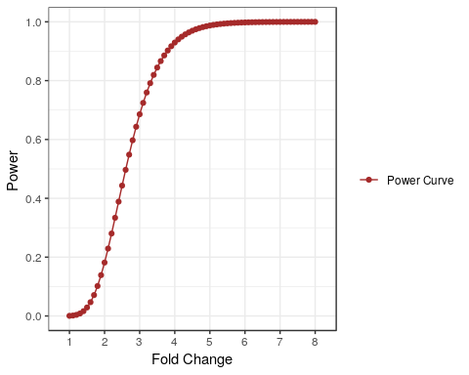

## 2. Next Generation Sequencing: Pre-Processing

### (a) Within geneLevelData, how many genes have all zeros as counts? How many have at least one sample with a zero?

## yeast RNA-seq data set on two mutant and two wildtype  
## strains  
data(geneLevelData)  
## also load the GC content and length  
data(yeastGC)  
data(yeastLength)  
## GC and gene length of montgomery data(uCovar)  
  
## genes have all zeros as counts  
zero_yeast <- sum(rowSums(geneLevelData) == 0)  
## at least one sample with a zero  
onezero_yeast <- sum(apply(geneLevelData, 1, function(x) {  
 any(x == 0)  
}))  
## only containing genes with ≥ 10 counts  
geneLevelDataFilter <- geneLevelData[rowSums(geneLevelData) >=   
 10, ]  
  
## SeqExpressionSet object for the EDASeq functions.  
exprs = as.matrix(geneLevelDataFilter) # matrix of counts  
sub = intersect(rownames(geneLevelDataFilter), names(yeastGC))  
exprs = exprs[sub, ] #only examine genes with annotated GC content/length  
row.names(exprs) = NULL #remove row and column names  
colnames(exprs) = NULL  
  
# Create SeqExpressionSet, which contains counts, labels for  
# the samples and GC content/length  
counts <- newSeqExpressionSet(counts = exprs, phenoData = data.frame(conditions = factor(colnames(geneLevelDataFilter))),   
 featureData = AnnotatedDataFrame(data.frame(gc = yeastGC[sub],   
 length = yeastLength[sub])))

557 genes have all zeros as counts. 1043 genes have at least one sample with a zero.

### (b) For the following plots, use the log scale

par(mfrow = c(1, 2))  
## To plot the counts by sample  
boxplot(counts)  
  
## plot the mean by variance plot a smoothScatter plot of the  
## mean variance relation a lowess fit  
meanVarPlot(counts, log = T)

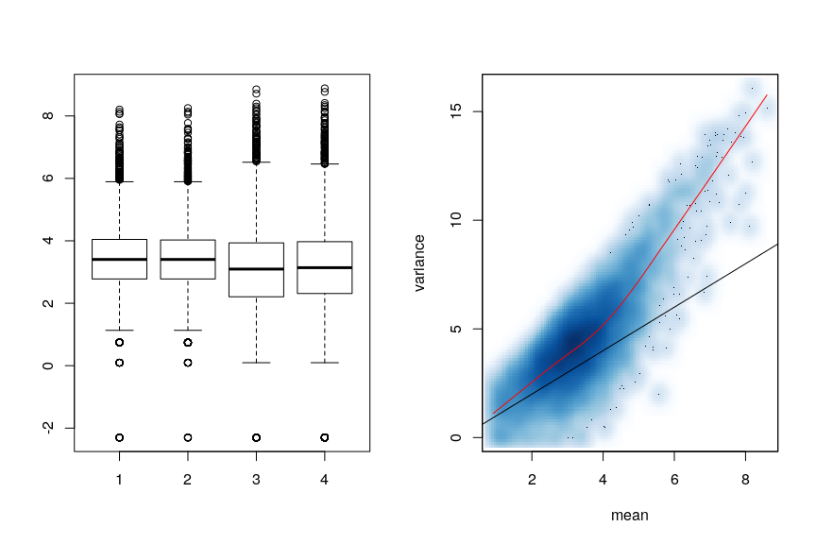

## To assess any biases by GC content  
biasPlot(counts, "gc", log = TRUE)  
  
## To assess any biases by length  
biasPlot(counts, "length", log = TRUE)

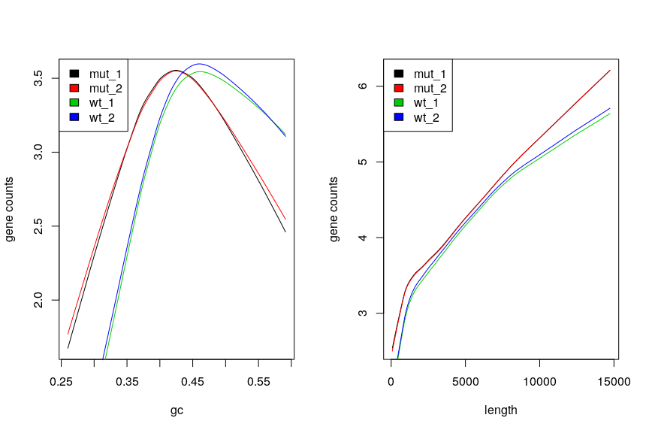

### (c) Apply withinLaneNormalization() to normalize by GC content.

par(mfrow = c(1, 2))  
## which=c('loess','median','upper','full') normalize by GC  
## content which = 'loess'  
norm_loess <- withinLaneNormalization(counts, "gc", which = "loess",   
 offset = FALSE)  
biasPlot(norm_loess, "gc", log = TRUE)  
  
## which = 'median'  
norm_median <- withinLaneNormalization(counts, "gc", which = "median",   
 offset = FALSE)  
  
biasPlot(norm_median, "gc", log = TRUE)

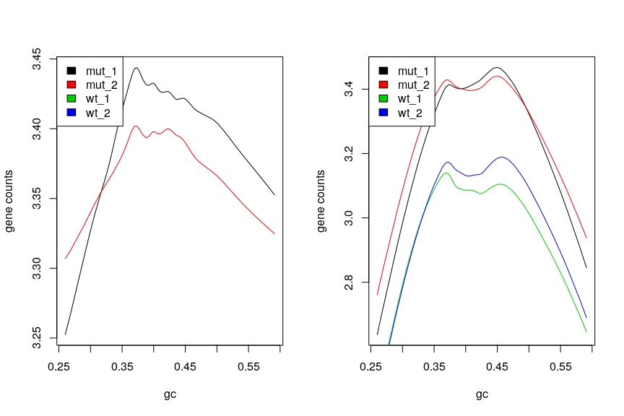

## which = 'upper'  
norm_upper <- withinLaneNormalization(counts, "gc", which = "upper",   
 offset = FALSE)  
  
biasPlot(norm_upper, "gc", log = TRUE)  
  
  
## which = 'full'  
norm_full <- withinLaneNormalization(counts, "gc", which = "full",   
 offset = FALSE)  
  
biasPlot(norm_full, "gc", log = TRUE)

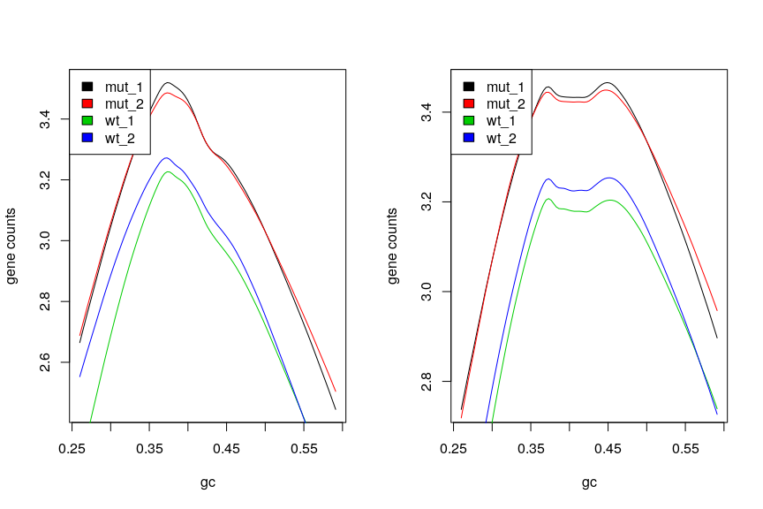

### (d) Using the within-lane normalized data from the previous part

par(mfrow = c(1, 2))  
biasPlot(counts, "gc", log = TRUE)  
## 'median','upper','full'  
bet_norm_median <- betweenLaneNormalization(norm_median, which = "median",   
 offset = FALSE)  
biasPlot(bet_norm_median, "gc", log = TRUE)

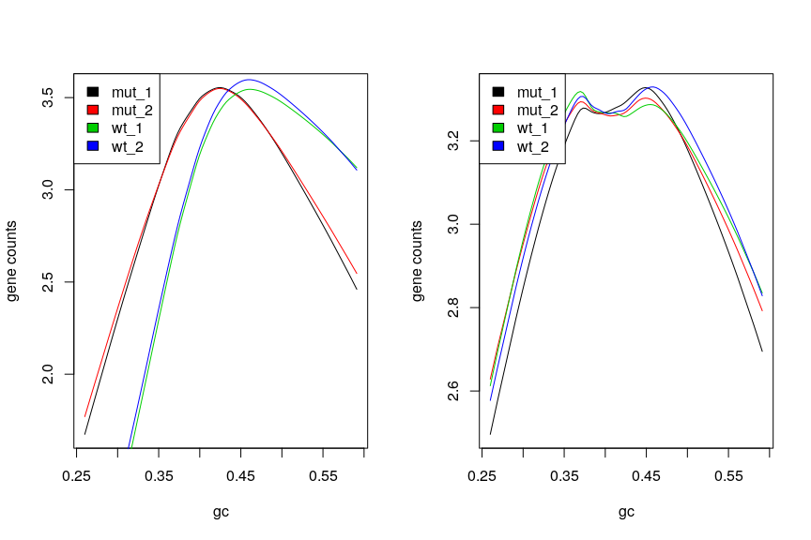

bet_norm_upper <- betweenLaneNormalization(norm_upper, which = "upper",   
 offset = FALSE)  
biasPlot(bet_norm_upper, "gc", log = TRUE)  
  
bet_norm_full <- betweenLaneNormalization(norm_full, which = "full",   
 offset = FALSE)  
biasPlot(bet_norm_full, "gc", log = TRUE)

